PREPARED FOR: | Sunshine Mills
TASK CODE: | SMBI-36 | DATE SUBMITTED: | 3/13/26
DESCRIPTION: | Tasklet Factory – Repack Production Orders
REQUESTED BY: | Kim Sparks
CREATED BY: | Eduardo Diaz

BUSINESS REQUIREMENT

This functionality is specific to the Tasklet Factory mobile app and not for Business Central.
Sunshine Mills (SSM) runs large production orders using white bags. Depending on the client’s demand, the product in those white bags will be repacked into specific packaging bags. Since all finished goods are palletized, SSM will need a function in the mobile app to repackage license plates.

PROPOSED SERVICES

- Repack Module: On the Tasklet Factory mobile app, add a new module for Repack. Upon opening the module, users should see only Released Production Orders with Repack set to true. Note that a previous customization added this Boolean field to the Business Central page. Users will need to navigate to the Consumption function and scan the license plate. After processing the consumption, the system should capture the quantity and lot number in memory. Note that there will always be one item and a lot number per license plate. Users will then navigate to the output feature to create a new license plate. The system should automatically populate the previously captured quantity and lot number before posting and printing a new LP. Example: Scan a license plate containing blank bags for item ABC with 100 units and lot L123. When posting output, the system should post the correct bag with the same quantity of 100 units and lot L123.

- Consumption Steps: Scan LP, confirm the quantity to consume, and post.
- Output Steps: Create a new LP, select pallet type, confirm quantity, lot number, and post & print.

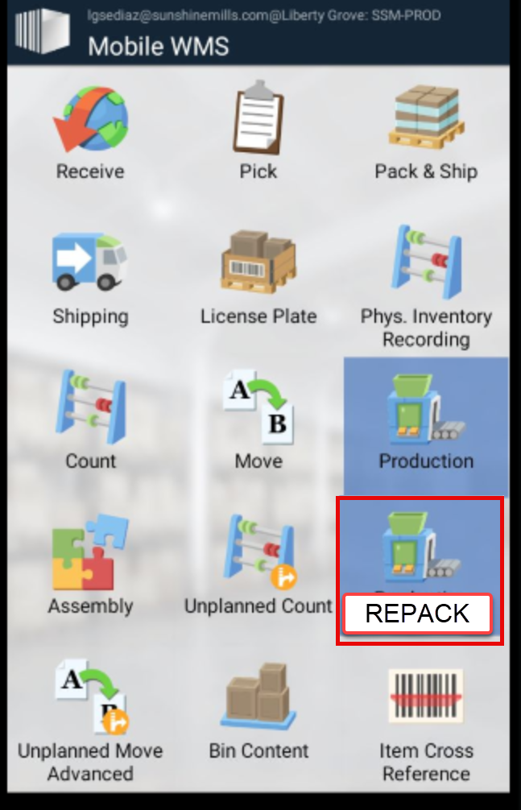

TESTING SCRIPTS

- On a Mobile device, open the Repack module
- Open a production order. Create one in Business Central if one doesn’t exist.
- Open the Consumption feature, scan a license plate with a white bag ingredient, and post consumption. Make sure to remember the quantity and lot number of the consumed license plate.
- Open the Output feature, create a new LP, select the pallet type to use, and validate that the quantity and lot number are the same as those of the previously consumed license plate. Post the output.
- Use the License Plate module to open the License Plate to revalidate the values.

ASSUMPTIONS/LIMITATIONS
Text
- Text
- Text

OTHER CONSIDERATIONS
None at this time.

TECHNICAL DESIGN
Text
- Text
- Text

PROFESSIONAL SERVICES ESTIMATE
 | Hours/Units | Rate |  | Total
Analysis, design, and write-up | 3 | 0.00 |  | $0.00
Technical design and estimate | X-X | 0.00 |  | $0.00
Development | X-X | 0.00 |  | $0.00
Testing & Deployment | X-X | 0.00 |  | $0.00
Total Professional Services Estimate* |  |  |  | $0.00
*Actual hours will be billed and may vary from the above estimate.

This Professional Services Estimate is valid 30 days from the Submitted Date.

APPROVAL

Client Acceptance Signature _________________________________ Date ________________

